**TUGAS PENGGANTI UTS**

**PEMROGRAMAN BASIS DATA**

Kelompok 16 :

Andika 211201171

Muhammad Hanif Atthariq 21120117140028

Fransiska Tebay 21120117100037

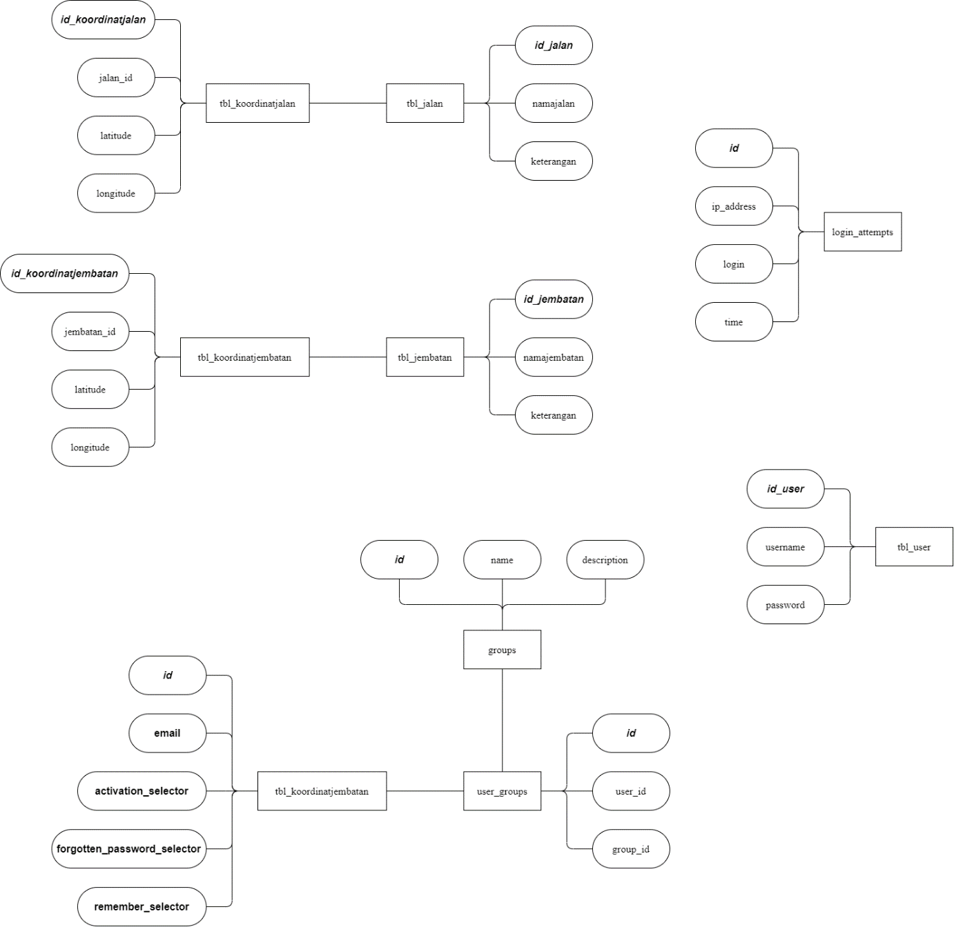

Gambar 1 *Entity Relationship Diagram*